TECHNICAL SPECIFICATION

Structure

- Mediterranean-style architecture and decor .
- Design reinforced concrete .

Walls

- External walls with double ceramic partitions, with an air chamber, thermal/acoustic insulation with polystyrene boards.
- Internal partition walls made of ceramic bricks. .

Coverage

- Plastering of vertical and horizontal surfaces with plaster and finishing with smooth white paint .
- Wallpaper on the main wall in the bedroom and living room (to be decided by the company's management)
- Smooth plasterboard ceilings and suspended ceilings (depending on installation) .
- Solarium with thermal and acoustic insulation in accordance with applicable regulations .
- The facade is finished with high-quality porcelain tiles, combined with a single-layer plaster in a color similar to the visualization, with a coating protecting against dirt
- High-quality porcelain flooring inside the building .
- Kitchens, bathrooms and laundries lined with high-quality ceramics .
- Outdoor floors on the porch, garden and solarium made of high-quality non-slip stoneware/porcelain .

Joinery
- External joinery made of high quality aluminum and electric shutters. Color (to be determined by the company's technical management).
- Climasun windows with increased thermal and acoustic insulation .
- Reinforced entrance door to the apartment, in the same RAL colour as the aluminium, with a three-point security system, knob and peephole .
- Door internal varnished , color (to be determined) By management Technical companies ).
- Built-in wardrobes in bedrooms, finished with the highest quality materials, with a top shelf, a hanging rail and drawers. Colour (to be agreed) By management Technical companies ).

Kitchen
- Kitchen furniture of modern design, with lower and upper cabinets, color (to be determined by the company's technical management).
- Countertops made of Silestone or similar material, color (to be determined by the company's technical management)
- Apartments designed with an independent utility room next to the kitchen, with space for a laundry room and a domestic hot water system (ACS) .

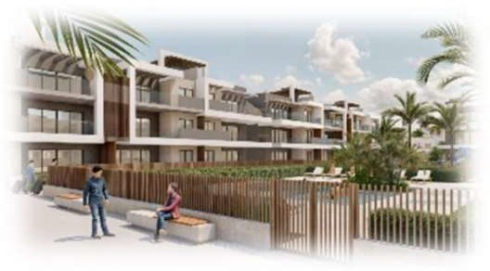

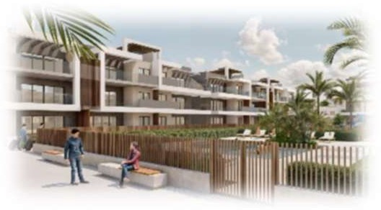
Bathrooms

- High-class hanging sanitary ware.
- Suspended cabinets under washbasins
- Single-handle and thermostatic taps in showers. .
- Bathrooms equipped with shower cabins and illuminated mirrors.
- Production of domestic hot water (DHW) using the ACS aerothermal system, in accordance with applicable regulations .

Air conditioning and ventilation

- Installation of air conditioning and ducted heating throughout the apartment .
- Underfloor heating throughout the entire apartment .
- Turbine-assisted mechanical ventilation in accordance with applicable regulations .

Installation Electric

- Electrical installation in accordance with applicable regulations .
- High-quality switches and sockets of the NIESSEN brand or equivalent.
- TV, telephone and internet points in all rooms of the apartment .

Zones external

- Water and electricity access points in solariums.
- Water access points in the ground floor gardens.
- Tempered glass balustrades on the solarium and terraces on the upper floors .
- External lighting of buildings included in the price. Project ( to be determined by the technical management of the company).

Included in the price

- Furniture and decorations in the apartment. (to be determined by the company's technical management )
- Household appliances included in the price .
- Installation of an outdoor kitchen, brick pergola, jacuzzi and artificial grass on the solarium .
- Private parking space and storage unit in the underground garage .
- Full lighting throughout the apartment .

Zones common

Ground floor
- Designer lighting tailored to the character of the estate. (to be determined by the company's technical management )
- Reception .
- Audiovisual room / conference room .
- Extensively areas green .
- Large swimming pool for adults and children's pool. .
- Place fun

Basement
- Spa ( heated pool) water , sauna, jacuzzi and thalassotherapy with the use of streams water ).
- Gym (fitness area equipped with spinning bikes, treadmills, multi-functional training equipment, bench and dumbbells of various weights ).

Ground floor apartments with spacious private garden and views of common areas.
First floor apartments with large terrace, wonderful views of common areas and the sea. Penthouses with large terraces and a solarium equipped with a private jacuzzi, designer pergola, artificial grass, summer kitchen, beautiful views of the common areas and a stunning view of the sea.
The quality and designs are indicative and do not constitute a commitment or part of the contract. The developer reserves the right to modify them due to construction requirements or the indications of the technical, commercial or legal management.

